ACCOMODATION OFFER – ALL PRICES ARE PER PERSON
HOTELS

HOTEL BOSNA
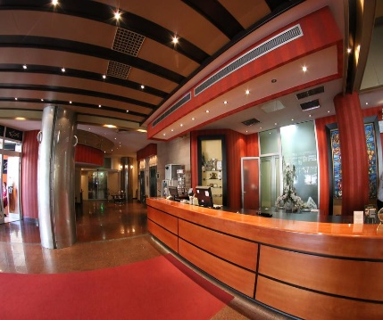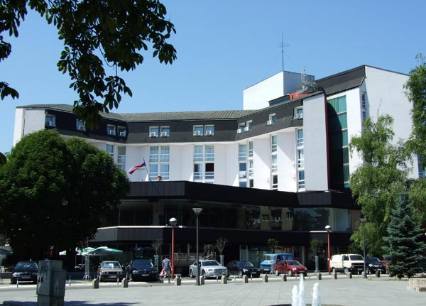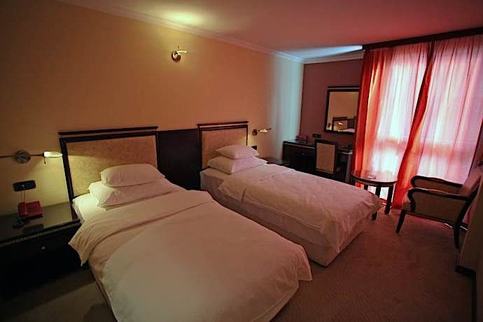
Hotel Bosna is one of the symbols of Banja Luka, built back in 1885. It is located in thecenter of the city, has a private parking, conference hall and a bar. Hotel Bosna has 5o stylish,fully-equipped rooms, for your pleasant stay. Distance from the hall 2km.
ALL PRICES ARE PER PERSON
HALF BOARD | 1/1 | 75e | WITH  BREAKFAST | 1/1 | 70e
 | 1/2 | 60e |  | 1/2 | 55e

HOTEL PALACE
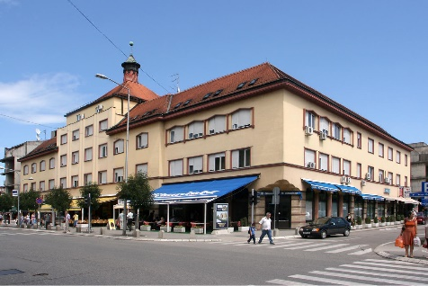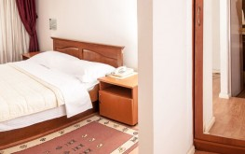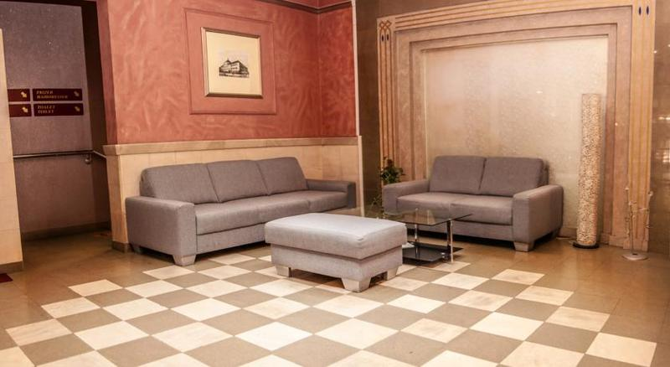
Hotel "Palas" was built in 1933, during the blooming period of Banja Luka, the time of the Vrbas banovina and Ban Svetislava Tisa Milosavljevic.The hotel is in the main street, with an overview on the City Square and the park. The hotel building is a protected monument of the architectural heritage of the first category.We have 69 rooms: 18 double and 49 single rooms, equipped with TVs, mini bar, direct telephone lines and internet. Distance from the hall 2km.
ALL PRICES ARE PER PERSON
HALF BOARD | 1/1 | 70e | WITH  BREAKFAST | 1/1 | 65e
 | 1/2 | 50e |  | 1/2 | 45e
 | 1/3 | 45e |  | 1/3 | 40e
 | 1/4 | 45e |  | 1/4 | 40e
 | 1/5 | 45e |  | 1/5 | 40e

HOTEL VIDOVIĆ
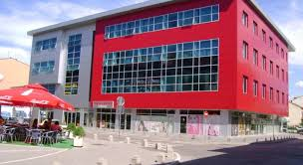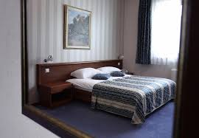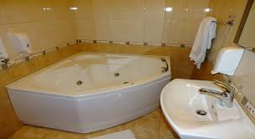
Hotel ‘’Vidović ‘’ is located in the center of town -next to the square and pedestrian zone. Republican and city institutions , cultural – historical monuments of the city are located within a radius of 500m from the hotel. This position and the concept of a hotel with all its hotel facilities make our offer irreplaceable choice when you arrive in the city on the river Vrbas. Distance from the hall 1,7km.
ALL PRICES ARE PER PERSON
HALF BOARD | 1/1 | 70e | WITH  BREAKFAST | 1/1 | 65e
 | 1/2 | 60e |  | 1/2 | 55e
 | 1/3 | 50e |  | 1/3 | 45e

HOTEL SLAVIJA

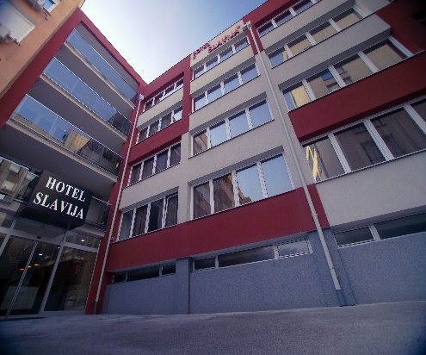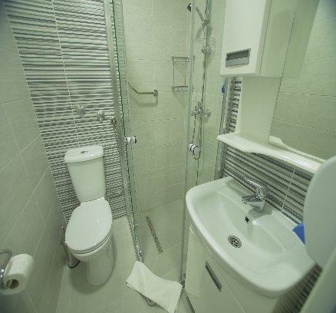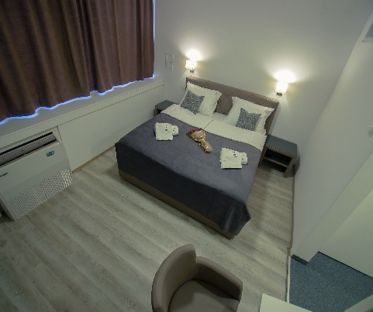
Hotel "Slavija" is located in the center of Banja Luka. Near the city council, the Krajina Square, Banovina Palace, the National Theater, the famous Gospodska street, fortress Kastel and other important sites in Banja Luka, you can reach the hotel on foot. In addition to its great location and the proximity of all major institutions in the city as well as national and cultural heritage of the city of Banja Luka, although it comes in the town center it is isolated from noise because it is surrounded by buildings and gives a form of intimacy and relaxation.. Distance from the hall 2km.
ALL PRICES ARE PER PERSON
HALF BOARD | 1/2 | 70e | WITH  BREAKFAST | 1/2 | 65e

HOTEL GRAND
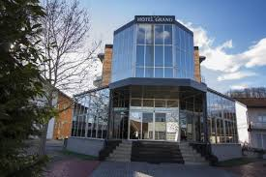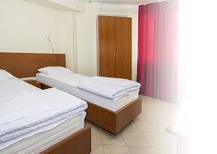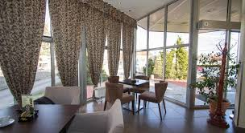
Located in a quiet part of Banja Luka, Hotel Grand is surrounded by greenery and offers an on-site bar and an à la carte restaurant and free Wi-Fi throughout the property. All rooms are air-conditioned and free private parking is available.All accommodation units come with an LCD TV and underfloor heating. Each one includes a bathroom with either a bathtub or a shower. Some units have a balcony. The hotel offers a car rental service, as well as shuttle service at a surcharge. Distance from the hall 6.5 km.
ALL PRICES ARE PER PERSON
HALF BOARD | 1/2 | 48e | WITH  BREAKFAST | 1/2 | 43e
 | 1/3 | 45e |  | 1/3 | 40e
 | 1/4 | 45e |  | 1/4 | 40e
 | 1/6 | 45e |  | 1/6 | 40e

HOTEL ĆUBIĆ
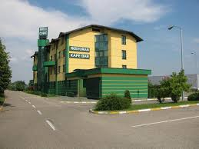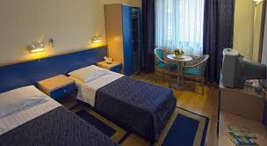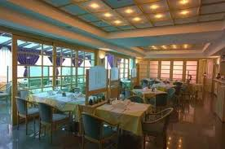
Ćubić Hotel is located on the highway Banja Luka - Klašnice in Glamočani.From the center of Banja Luka is 12 km from Gradiska and the Croatian border 35 km. Since it is a frequented road communication, 7 km from the international airport of Banja Luka, Ćubić Hotel is an ideal place for business travelers as well as for other guests who come to Banja Luka and the environment. This location makes us fit and support the fair, congress, hunting and other kinds of tourism.Since the Hotel Ćubić operates through fifteen years, we have vast experience in the hotel business, a young and professional team of employees ready to respond to the major challenges and tasks that are placed before them. Distance from the hall 12km.
ALL PRICES ARE PER PERSON
HALF BOARD | 1/2 | 40e | WITH  BREAKFAST | 1/2 | 35e
 | 1/3 | 40e |  | 1/3 | 35e
 | 1/4 | 40e |  | 1/4 | 35e
 | 1/6 | 40e |  | 1/6 | 35e

HOTEL ĆETOJEVIĆ

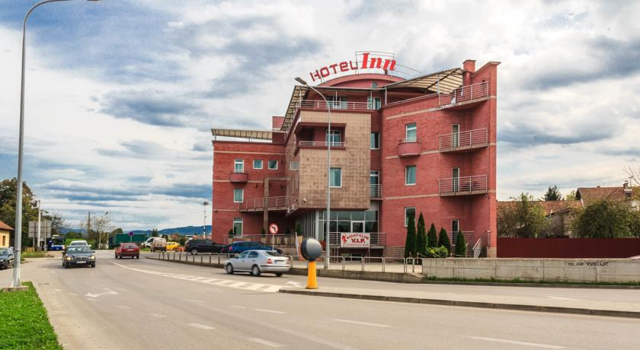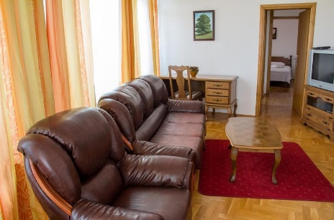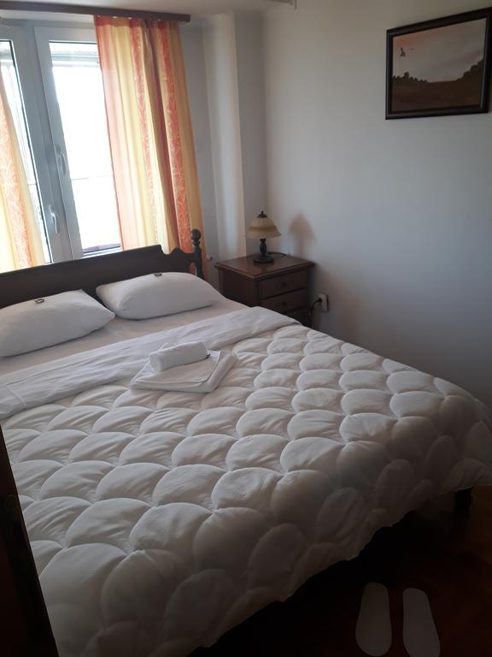
The hotel is placed when entering Banja Luka, it is some 2,5-3 km far away from the center,he rooms are with air condition, TV, hairdryer, the towels are changed every day. Hotel has 20 stylish,fully-equipped rooms, for your pleasant stay. Distance from the hall 2,6km.
ALL PRICES ARE PER PERSON
HALF BOARD | 1/2 | 40e | WITH  BREAKFAST | 1/2 | 40e
 | 1/3 | 37e |  | 1/3 | 37e
 | 1/4 | 37e |  | 1/4 | 37e

HOTEL COURTYARD by MARRIOTT
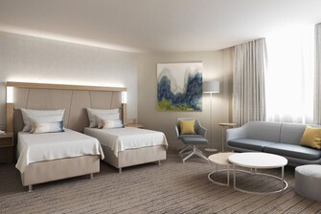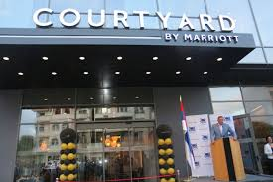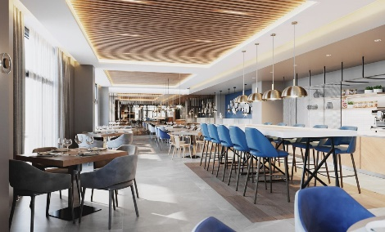
The new state-of-the-art lobby at Courtyard provides greater flexibility and choices for our guests. At the center of it all is Bar, your destination for a great breakfast, or drinks and dinner during the evening. You'll also enjoy inviting, flexible spaces where you can work or relax, free Wi-Fi throughout and easy access to the latest news. Plus, our well-equipped fitness center, will help you stay refreshed and energized. Whether traveling for business or pleasure, your stay at Courtyard is sure to be more comfortable, more productive and more enjoyable than ever before. Distance from the hall 1.8km
ALL PRICES ARE PER PERSON
HALF BOARD | 1/2 | 65e | WITH  BREAKFAST | 1/2 | 65e

APARTMENTS AND MOTELS

MOSKVA
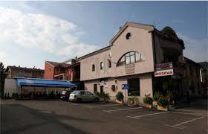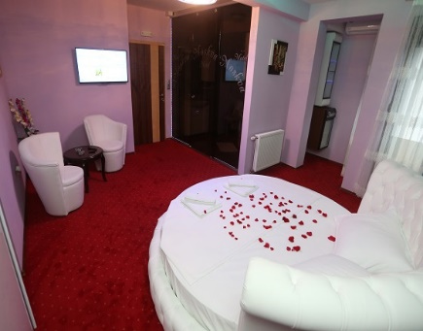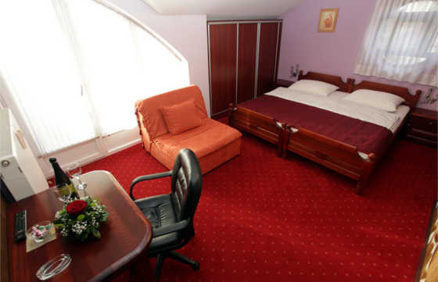

Motel Moskva is located in the center of Banja Luka. Our newly equipped motel has a capacity of 30 beds. Exclusive apartments are a guarantee for your pleasant stay, Luxuriously furnished rooms are covered with Wi-Fi internet signal, and each room has a plasma TV and air conditioning. Distance from the hall 2.3km.
ALL PRICES ARE PER PERSON
HALF BOARD | 1/2 | 40e | WITH  BREAKFAST | 1/2 | 40e
 | 1/3 | 35e |  | 1/3 | 35e
 | 1/4 | 35e |  | 1/4 | 35e

MIG
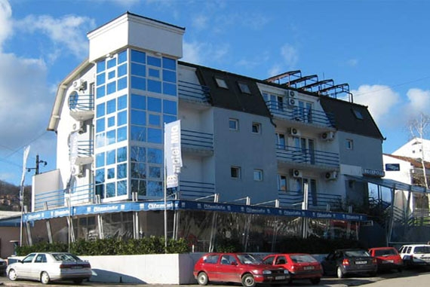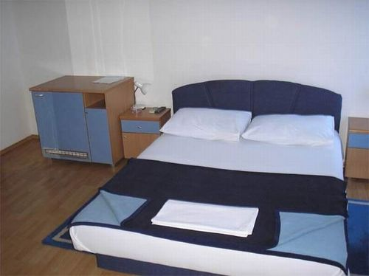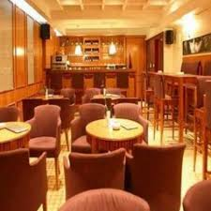
The Motel is located at the southern entrance to Banja Luka. It has 15 rooms equipped with bathroom, air conditioning, mini bar and 3 suites with hydromassage bathtubs. The motel has a restaurant. Guests are provided with parking. Distance from the hall 2.7km.

ALL PRICES ARE PER PERSON
HALF BOARD | 1/2 | 40e | WITH  BREAKFAST | 1/2 | 35e
 | 1/3 | 40e |  | 1/3 | 35e
 | 1/4 | 40e |  | 1/4 | 35e

GOLDEN CARD
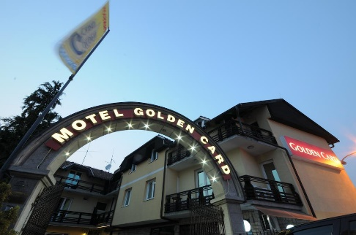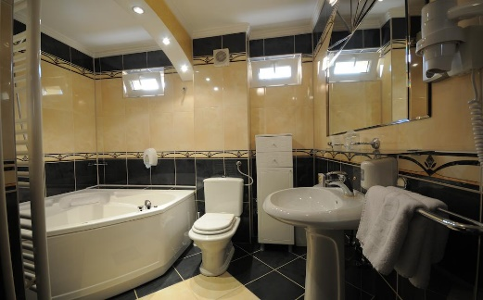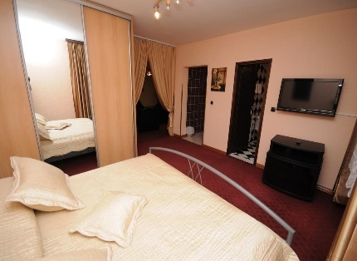
Motel Golden Card Motel includes a restaurant with a grocery, a terrace bar, air-conditioned accommodation with free Wi-Fi and free parking. It is located opposite the supermarket. Distance from the hall 2.2km.
ALL PRICES ARE PER PERSON
HALF BOARD | 1/2 | 45e | WITH  BREAKFAST | 1/2 | 40e
 | 1/3 | 40e |  | 1/3 | 35e
 | 1/4 | 40e |  | 1/4 | 35e

RS
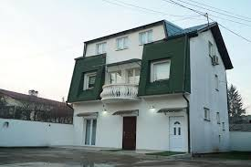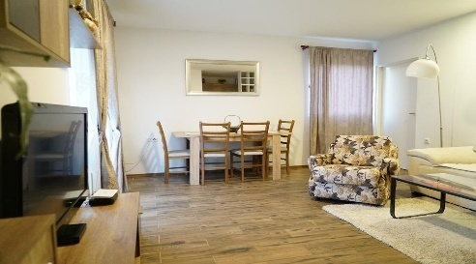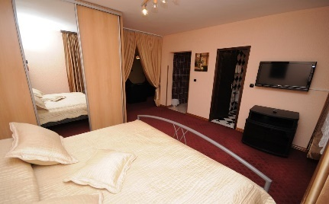
Apartments RS are located in thecenter of the city, right next to the Patra Bridge and Fortress Kastel. Each apartment is air-conditioned, equipped with a mini kitchen with all necessary elements, LCD TV with cable connection, WiFi and private bathrooms. Distance from the hall 2.5km.
ALL PRICES ARE PER PERSON
HALF BOARD | 1/4 | 40e | WITH  BREAKFAST | 1/4 | 35e

SC NIKOLA TESLA
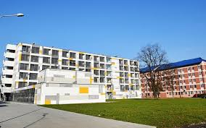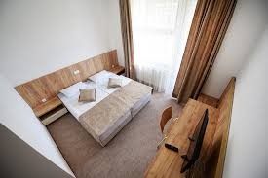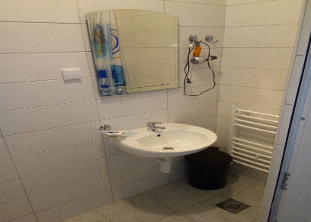
Fully equipped, single and double rooms will meet all of your expectations for a peaceful and pleasant stay in our city. The rooms are covered with wi fi signal, they have cable TV and are air-conditioned. Within the Campus there is also a parking space for our guests. Distance from the hall 150m..
ALL PRICES ARE PER PERSON
HALF BOARD | 1/3 | 40e | WITH  BREAKFAST | 1/3 | 35e
 | 1/4 | 40e |  | 1/4 | 35e

BROOKLYN
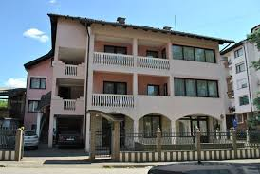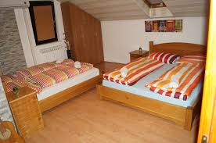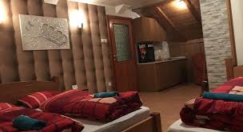

Brooklyn Apartments offer excellent services in a pleasant ambience and offers spacious, comfortable apartments and rooms. All rooms and suites are equipped with high speed internet connection, air conditioning, tv / sat. Distance from the hall 2.2km.
ALL PRICES ARE PER PERSON
HALF BOARD | 1/2 | 40e | WITH  BREAKFAST | 1/2 | 35e
 | 1/3 | 40e |  | 1/3 | 35e
 | 1/4 | 40e |  | 1/4 | 35e
 | 1/6 | 40e |  | 1/6 | 35e

ORTODOX

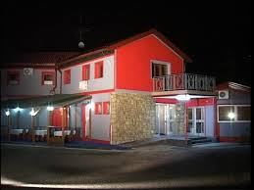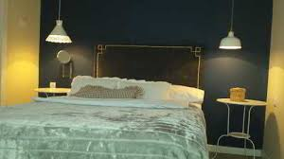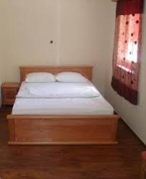
Are located on the main road Banja Luka - Jajce, in the village of Novoselija, about 6 km from the city center. Apartments offer excellent services in a pleasant ambience and offers spacious, comfortable apartments and rooms. Distance from the hall.7km.

ALL PRICES ARE PER PERSON
HALF BOARD | 1/2 | 40e | WITH  BREAKFAST | 1/2 | 35e
 | 1/3 | 40e |  | 1/3 | 35e

EM
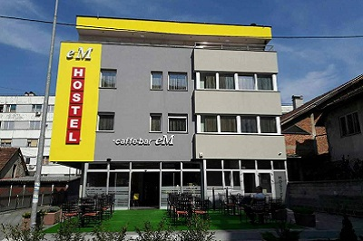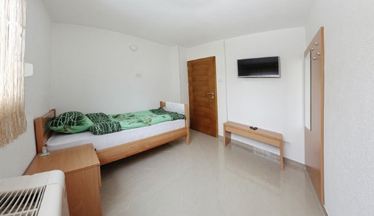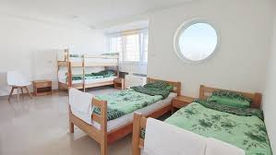

.eM Hostel is located in Obilićevo settlement in Banja Luka. Each room has TV, internet, and if necessary we also have a laundry service. On the ground floor of the hostel there is a peaceful cafe where you can start the day, and the entire hostel is surrounded by a parking space reserved for our guests.Distance from the hall 2.3km
ALL PRICES ARE PER PERSON
HALF BOARD | 1/2 | 35e | WITH  BREAKFAST | 1/2 | 30e
 | 1/3 | 35e |  | 1/3 | 30e
 | 1/4 | 35e |  | 1/4 | 30e
 | 1/6 | 35e |  | 1/6 | 30e

KAMEL
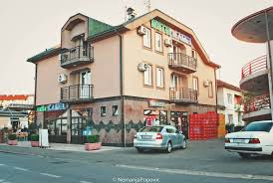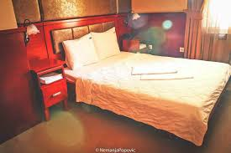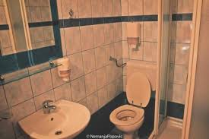
Located near the centre of Banja Luka featuring various cultural centres and museums, Hotel Kamel offers air-conditioned rooms with free Wi-Fi. The River Vrbas known for its waterfalls can be found 2 km from the property.Rooms at Kamel Hotel provide cable TV and wooden furnishings. Private bathrooms come with a bathtub or a shower, and offer free toiletries.The hotel restaurant offers local and international cuisine. A garden and a patio are available as well. More dining options can be found in the city centre.. Distance from the hall 2.6km.
ALL PRICES ARE PER PERSON
HALF BOARD | 1/1 | 50e | WITH  BREAKFAST | 1/1 | 45e
 | 1/2 | 45e |  | 1/2 | 40e
 | 1/3 | 45e |  | 1/3 | 40e
 | 1/4 | 45e |  | 1/4 | 40e

CENTAR 1
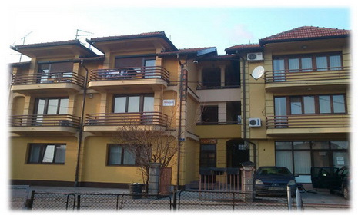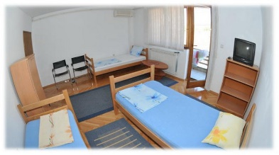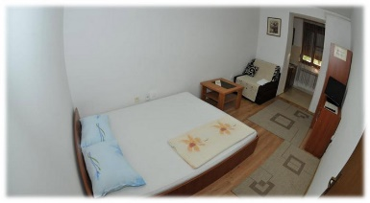
Centar 1 is located in the very heart of Banja Luka, on the green coast of Vrbas, about 2 km from the main railway and bus station, while Banja Luka Airport is 15 km away. Distance from the hall 1.8km.
ALL PRICES ARE PER PERSON
HALF BOARD | 1/2 | 35e | WITH  BREAKFAST | 1/2 | 30e
 | 1/3 | 35e |  | 1/3 | 30e
 | 1/4 | 35e |  | 1/4 | 30e
 | 1/6 | 35e |  | 1/6 | 30e

LARISA
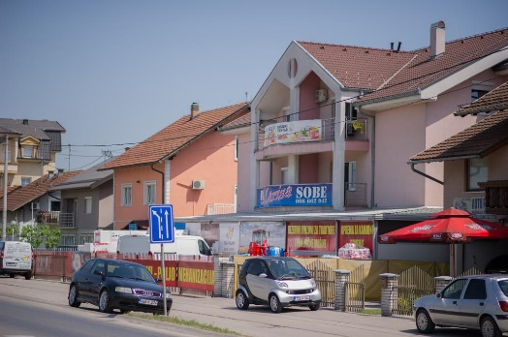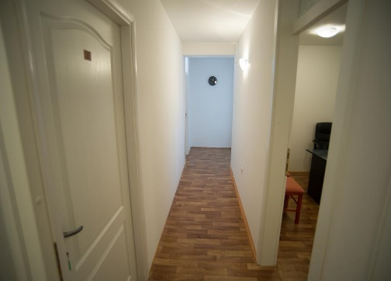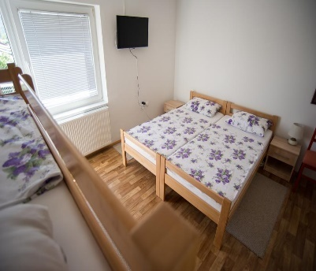
Larisaapartments offer excellent services in a pleasant ambience and offers spacious, comfortable apartments and rooms. Distance from the hall istance from the hall 4.8km
ALL PRICES ARE PER PERSON
HALF BOARD | 1/4 | 35e | WITH  BREAKFAST | 1/4 | 30e

