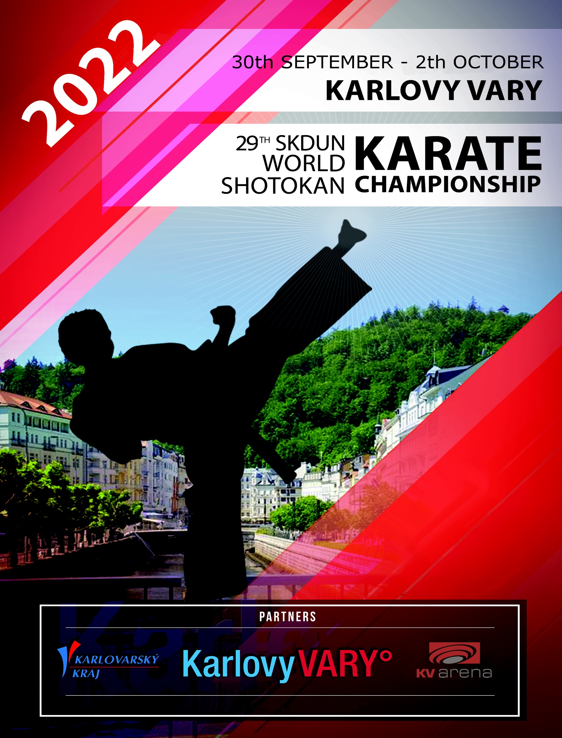

SHOTOKAN KARATE-DO OF UNITED NATIONS
CZECH ASSOCIATION OF OKINAWAN KARATE AND KOBUDO CZECH REPUBLIC

with the support of City of Karlovy Vary and Karlovarsky Region
have the honour and pleasure to invite you to the

29th SKDUN World Shotokan Karate Championship
14th SKDUN World Shotokan Karate Cup

held at Sports hall “KV arena Karlovy Vary“
Západní 1812/73, 36001 Karlovy Vary

30 SEPTEMBER – 02 OCTOBER 2022
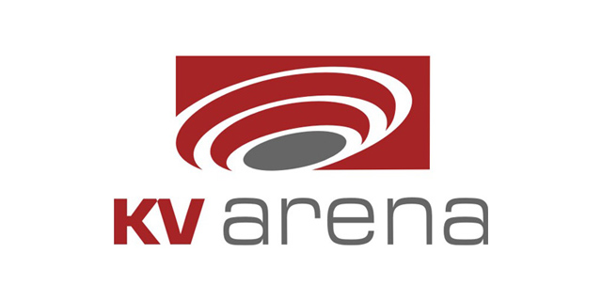
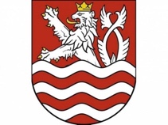
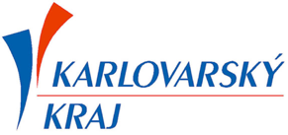
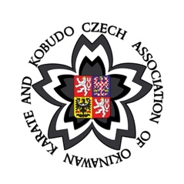

We wish you a warm welcome and a pleasant stay in the City of Karlovy Vary.

ORGANISING COMMITTEE

Aurel Patru – President of Shotokan Karate-do of United Nations
E-mail: aurelpatruskdun@gmail.com / aurel.patru@skdun.org
Mobile: +40722385780

Colin Putt – Technical Director and Chief Referee of Shotokan Karate-do of United Nations
E-mail: colin.putt@skdun.org Mobile:+447968061887

Anton Vandev – Chief Referee Designate of Major Competition Shotokan Karate-do of United Nations
E-mail: bagatur75@abv.bg Mobile +359882433899

Daniel Pekuniak – President of Czech association of Okinawan karate and kobudo Czech Republic
E-mail: daniel.pekuniak@caokk.cz Mobile: +420775013151

Miroslav Boguský – Event manager for transport, catering and visas
E-mail: miroslav.bogusky@caokk.cz Mobile: +420606131845

Martin Špalek – Event manager for accommodation
Email: booking@in-travel.eu Mobile: +420 777893274

HOW TO GET TO KARLOVY VARY from Prague Airport (Vaclav Havel Airport)

The Organising Committee will arrange transport by bus/minibus from the airport.

YOU MAY NEED TO WAIT AT THE AIRPORT TO JOIN ANOTHER GROUP.

At the airport you will find a contact person who will accompany you to the Hotel or Sports Hall to make the registration, they will be easily identified by a logo of SHOTOKAN KARATE-DO OF UNITED NATIONS.

ACCOMMODATION
To arrange your accommodation please contact Mr. Martin Špalek by e-mail: booking@in-travel.eu, providing him with all the necessary information (your choice hotel name, number of people in your group, list of rooms required, number of nights etc.)

VISA
Participants who need a VISA must contact Miroslav Boguský as soon as possible, time delays may result in your visa not being granted in time for the event. This is your responsibility.
The last date for sending invitation letters for visa approval is 30th August 2022.

COVID 19 rules
Conditions for entering the Czech Republic:
https://www.mvcr.cz/mvcren/article/coronavirus-information-of-moi.aspx

OFFICIALS
Referees and Judges must register on Sportdata before 15th September if they want to be selected as officials.

The Chief Referee will approve registered referees and judges, SKDUN qualified referees and judges will have their previously issued ID and qualification badges, these will allow automatic entry as SKDUN officials to all areas of the venue as required. Please remember to bring your SKDUN official issued ID and ties, red for referees and blue for judges. Don’t forget your whistle!

Non-SKDUN qualified applicants, if selected, will have a badge issued as required by the competition Chief Referee Designate, Anton Vandev. Any enquiries or questions contact Anton Vandev, Email: bagatur75@abv.bg , Mobile: +359882433899

Referees and judges, please ensure you have registered on Sportdata and include the days you will be available. IMPORTANT, please let the Chief Referee, Anton Vandev know in advance if you have registered but cannot attend due to illness, work etc. Those who are also competing (only allowed in Asai Ryu / Veteran categories, no other categories), please let him know in which categories you entered in order for him to accurately schedule and allocate officials to the various shiai-jo.

EVENTS SCHEDULE
Thursday 29th September
15:00 – 21:00 – REGISTRATION AND WEIGH-IN FOR COMPETITORS
KV arena Karlovy Vary, Západní 1812/73, 36001 Karlovy Vary.

Without the weight check, competitors will not be permitted to participate in kumite events.

Team managers must collect the identity badges for their Sportdata registered competitors, coaches and officials.
There will be NO ACCESS to the Sport Hall without identification card/badge.

Only in exceptional circumstances and by prior agreement with the organiser, Daniel Pekuniak, and the Chief Referee, Anton Vandev, will it be possible to do the registration and weigh-in in the Sport Hall on Friday 30th September.

Sportdata registration requirements:
All participants must register on Sportdata. A passport type photo must be included.
Officials can register for one role only i.e. coach, judge, head of delegation etc.

For information about and support with registration on Sportdata please contact Chief of competition secretariat Mr. Bogdan Brata (mobile: 0040745168006, email: bogdanbrata@yahoo.com).

Friday 30th September
09:00 – 13:00 29th SKDUN World Karate Championship (Veterans all categories, Seniors: kata individual, kata Asai Ryu, kata teams)
14:00 – 19:00 14th SKDUN World Karate Cup

Saturday 1st October
09:00 – 12:00 14th SKDUN World Karate Cup / 29th SKDUN World Karate Championship
12:00 – 19:00 29th SKDUN World Karate Championship

Sunday 2nd October
09:00 – 19:00 29th SKDUN World Karate Championship

DEADLINE FOR REGISTRATION ON SPORTDATA IS 15th of SEPTEMBER
DETAILED COMPETITION SCHEDULE/TIMETABLE WILL BE AVAILABLE AFTER THE REGISTRATION DEADLINE ON SPORTDATA
AWARDS
29th SKDUN World Shotokan Karate Championship (3 kyu – Dan grade)
- Medal and diploma for 1st, 2nd and 3rd place in individual events
- Trophy cup for team, and diplomas and medals for team members in team events
- Special trophy cups for 1st, 2nd, 3rd, 4th and 5th places for BEST RANKING NATIONAL TEAMS!
14th SKDUN World Shotokan Karate Cup (9 – 4 kyu)
- Medal and diploma for 1st, 2nd and 3rd place in individual events
- Trophy cup for team, and diplomas and medals for team members in team events
- Special trophy cups for 1st, 2nd, 3rd, 4th and 5th places for BEST RANKING NATIONAL TEAMS!
All competitors will receive a certificate of participation.
NO SPORTDATA ENTRIES WILL BE PERMITTED AFTER 15th September 2022 unless agreed with the SKDUN ORGANISING PRESIDENT and CHIEF REFEREE.
ENTRY FEES

Individual events - 30€ per person per event

Kata and Kumite Team events - 60€ per team per event
Duo Kata – 40 € per team

Registration fees for coaches – 30€ per coach
To protest - 50€ per protest (only one protest is allowed during one match if the protest is not correct)
NOTE: Late registrations might be accepted at the organisers’ discretion and only in exceptional circumstances.
There will be an ADDITIONAL LATE ENTRY ADMINISTRATION FEE for any accepted late registration after 15th September (+10€ for individual events and +25€ for team events).

